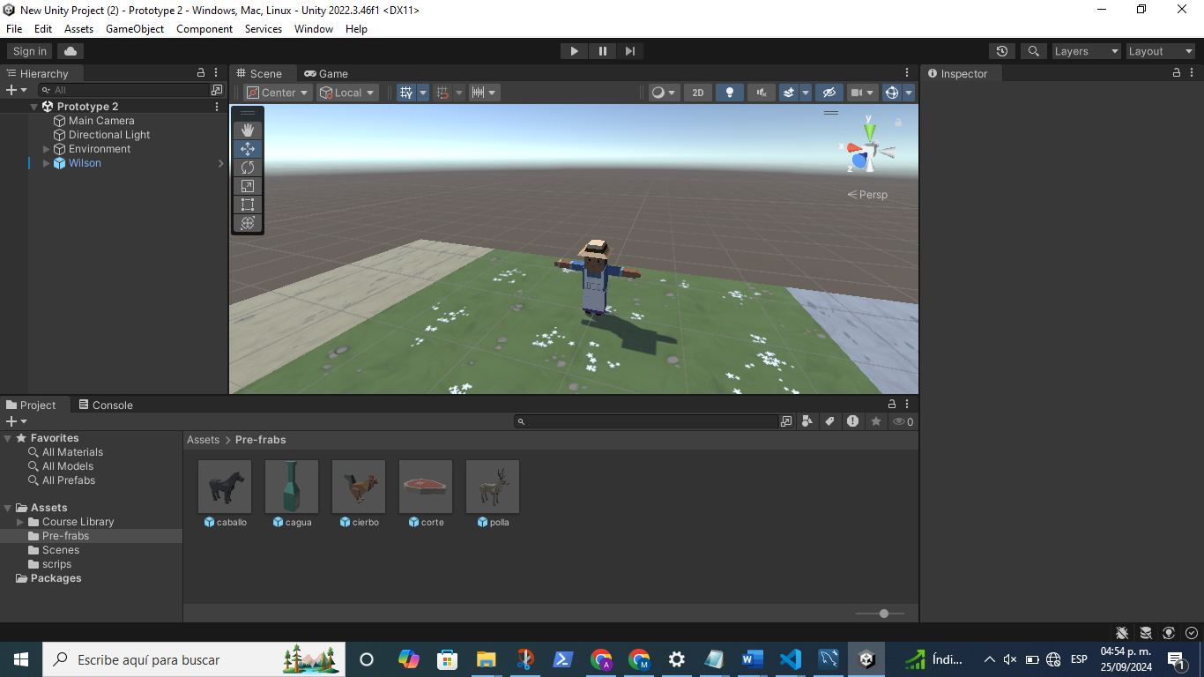

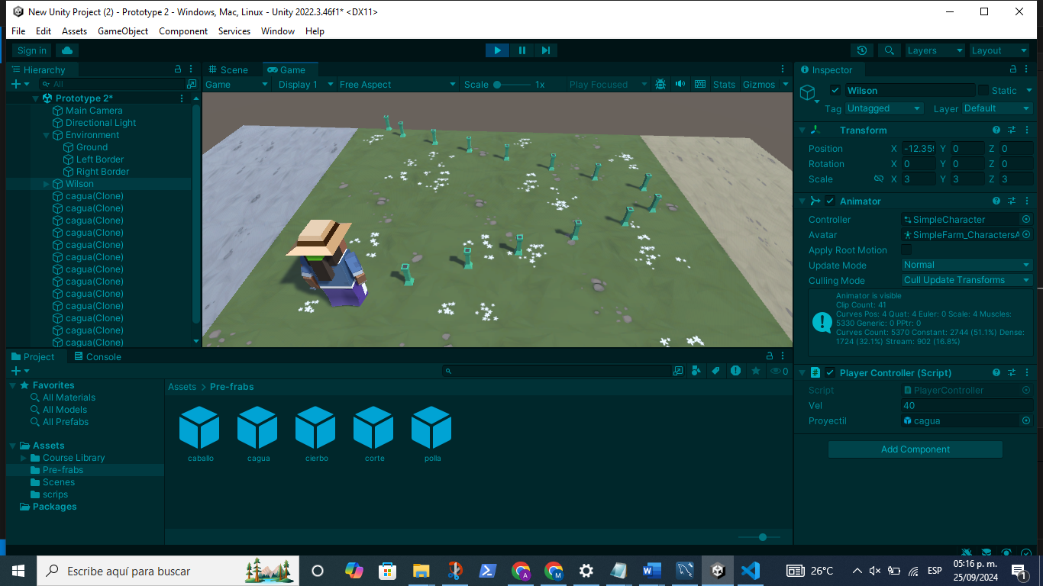

using System.Collections;

using System.Collections.Generic;

using UnityEngine;

/\*\*\*\*\*\*\*

  \*Descripcion: mueve adelante

  \*Autor: Saul Guadalupe Marin Reyes

  \*Fecha: 25/09/2024

\*\*/

public class PlayerController : MonoBehaviour

{

    public float vel = 15F;

    public GameObject proyectil;

    // Start is called before the first frame update

    void Start()

    {

    }

    // Update is called once per frame

    void Update()

    {

        float x = Input.GetAxis("Horizontal");

        if (transform.position.x > 20)

        {

            transform.position = new Vector3(20, transform.position.y, transform.position.z);

        } else if (transform.position.x < -20)

        {

            transform.position = new Vector3(-20, transform.position.y, transform.position.z);

        }

        if (Input.GetKeyDown(KeyCode.Space))

        {

            Instantiate(proyectil, transform.position, proyectil.transform.rotation);

        }

        transform.Translate(Vector3.right \* Time.deltaTime \* vel \* x);

    }

}

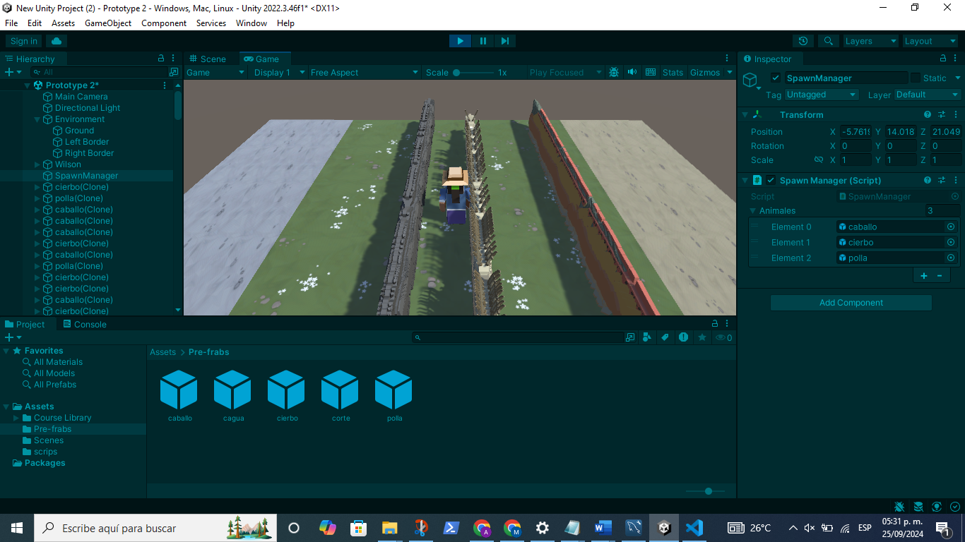

using System.Collections;

using System.Collections.Generic;

using UnityEngine;

/\*\*\*\*\*\*\*

  \*Descripcion: mueve adelante

  \*Autor: Saul Guadalupe Marin Reyes

  \*Fecha: 25/09/2024

\*\*/

public class MuveaAdelante : MonoBehaviour

{

    public float vel= 10F;

    // Start is called before the first frame update

    void Start()

    {

    }

    // Update is called once per frame

    void Update()

    {

        if(transform.position.z > 35){

            Destroy(gameObject);

        }else if (transform.position.z < -15){

            Destroy(gameObject);

        }

        transform.Translate(Vector3.forward\*Time.deltaTime\*vel);

    }

}

Animales

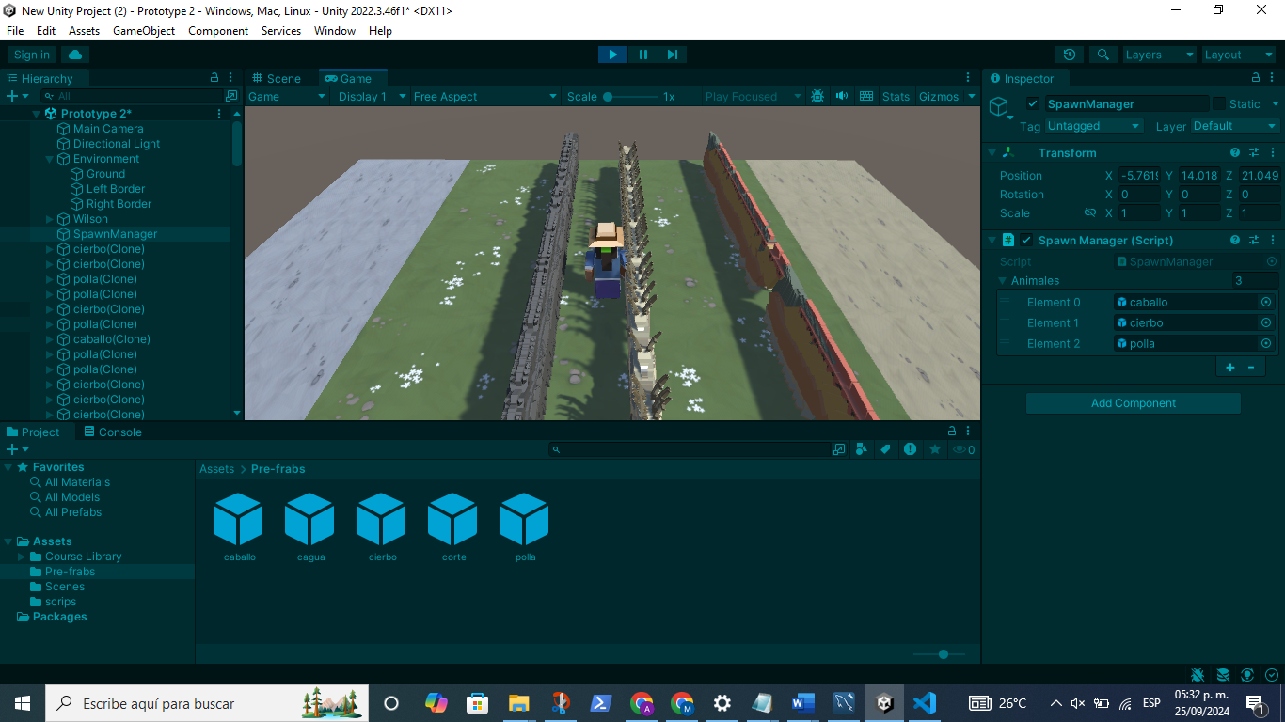

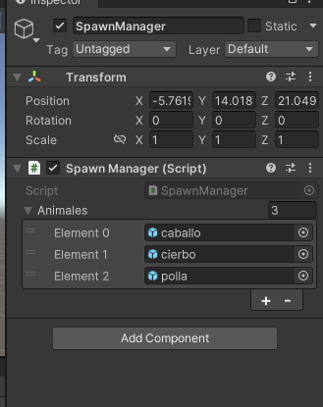

using System.Collections;

using System.Collections.Generic;

using UnityEngine;

/\*\*\*\*\*\*\*

  \*Descripcion: mueve adelante

  \*Autor: Saul Guadalupe Marin Reyes

  \*Fecha: 25/09/2024

\*\*/

public class SpawnManager : MonoBehaviour

{

    public GameObject[] animales;

    // Start is called before the first frame update

    void Start()

    {

    }

    // Update is called once per frame

    void Update()

    {

        int index = Random.Range(0,3);

        Instantiate(animales[index], animales[index].transform.position,

        animales[index].transform.rotation);

    }

}

